Figure Legends:

Fig.1 Correlation between Endothelial Progenitor Cells (EPCs) and Interleukin-1 (IL-1) in seropositive RA.

Fig.2 Correlation between Endothelial Progenitor Cells (EPCs) and Tumour Necrosis Factor-α (TNF-α) in seropositive RA.

Fig.3 Correlation between Endothelial Progenitor Cells (EPCs) and Disease Activity Score of 28 joints (DAS 28) in seropositive RA.

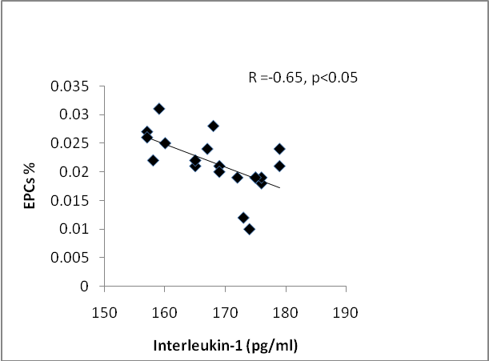
Fig 1. Correlation between Endothelial Progenitor Cells (EPCs) and Interleukin-1 (IL-1) in seropositive RA.
^{* p ≤ 0.05, significant values}

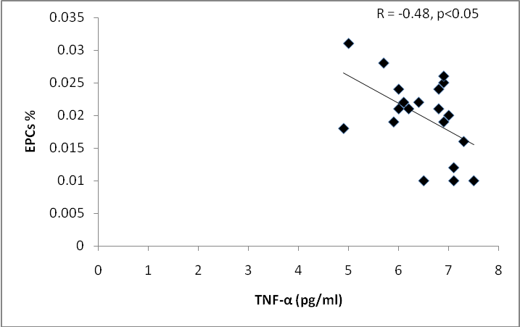
Fig. 2 Correlation between Endothelial Progenitor Cells (EPCs) and Tumour Necrosis Factor-α (TNF-α) in seropositive RA.
^{* p ≤ 0.05, significant values}

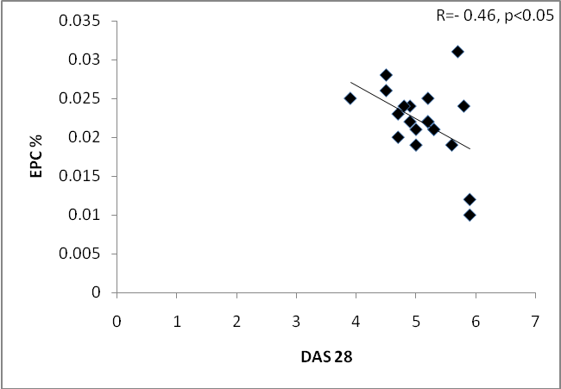
Fig. 3 Correlation between Endothelial Progenitor Cells (EPCs) and Disease Activity Score of 28 joints (DAS 28) in seropositive RA.
^{* p ≤ 0.05, significant values}

