Figures of Case report on POEMS Syndrome

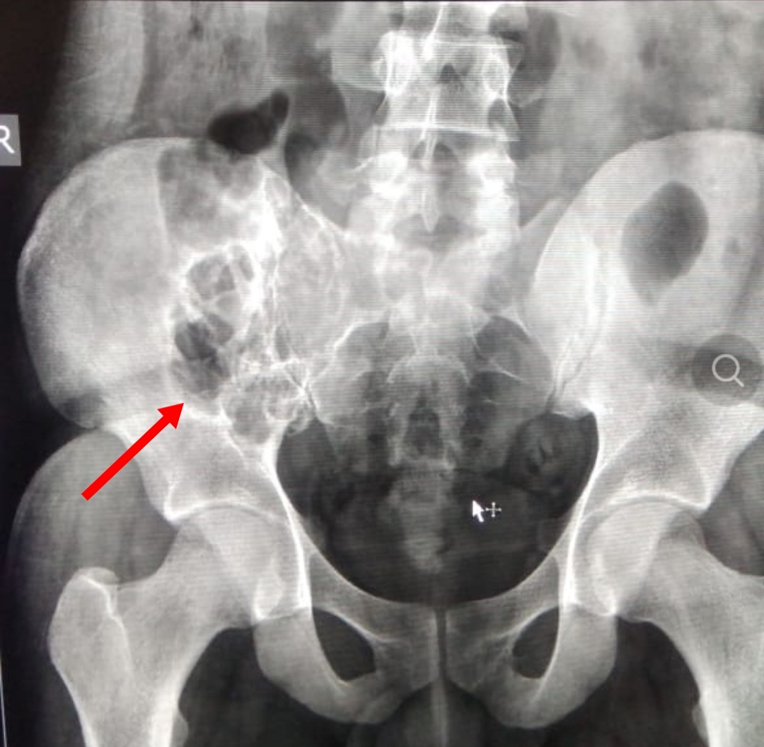

Fig 1 Right iliac bone plasmocytoma

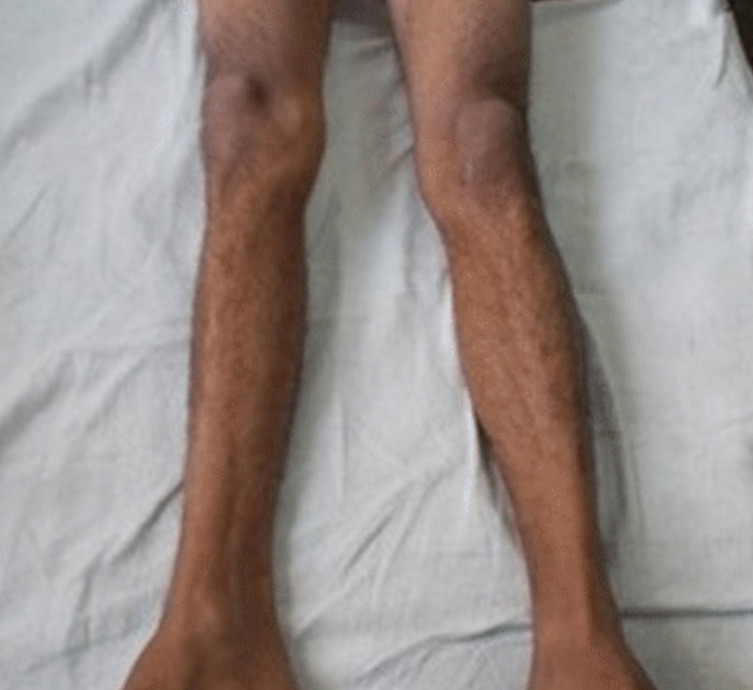

Fig 2 Skin changes in the lower limbs