To,

Covering Letter

The Editor

**Sub:** Submission of Manuscript for publication

Dear Sir,

We intend to publish an article entitled “**Polyarticular charcot: a rare case report and a literature review in Indian context**” in your esteemed journal as a Case/Brief Report with literature review.

On behalf of all the contributors I will act and guarantor and will correspond with the journal from this point onward.

Prior publication (of same manuscript) - Nil

Support- Nil

Conflicts of interest- Nil

Permissions - Nil

We hereby transfer, assign, or otherwise convey all copyright ownership, including any and all rights incidental thereto, exclusively to the journal, in the event that such work is published by the journal.

We would like to suggest following referees for the article - Nil

Thanking you,

Yours’ sincerely,

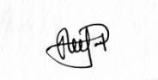

Signature

**Corresponding contributor:** Dr Jeet Patel, DNB-SS in Rheumatology,

**Postal address**: Arthritis Rheumatology Clinic, 202, shyam arena, 14 A, B, sampatrao colony, Vadodara, Gujarat.

**Phone number**: +91-9821808588

**Mail I.D** – jeet5patel5@gmail.com

Encl: Contributor’s form signed by all the contributors

Checklist

### Contributors' form

**Manuscript Title: ­** **Polyarticular charcot: a rare case report and a literature review in Indian context**

we certify that we have participated sufficiently in the intellectual content, conception and design of this work or the analysis and interpretation of the data (when applicable), as well as the writing of the manuscript, to take public responsibility for it and have agreed to have our name listed as a contributorwe believe the manuscript represents valid work. Neither this manuscript nor one with substantially similar content under our authorship has been published or is being considered for publication elsewhere, except as described in the covering letter. we certify that all the data collected during the study is presented in this manuscript and no data from the study has been or will be published separately. we attest that, if requested by the editors, we will provide the data/information or will cooperate fully in obtaining and providing the data/information on which the manuscript is based, for examination by the editors or their assignees. Financial interests, direct or indirect, that exist or may be perceived to exist for individual contributors in connection with the content of this paper have been disclosed in the cover letter. Sources of outside support of the project are named in the cover letter.

We hereby transfer(s), assign(s), or otherwise convey(s) all copyright ownership, including any and all rights incidental thereto, exclusively to this journal, in the event that such work is published by the journal. The journal shall own the work, including 1) copyright; 2) the right to grant permission to republish the article in whole or in part, with or without fee; 3) the right to produce preprints or reprints and translate into languages other than English for sale or free distribution; and 4) the right to republish the work in a collection of articles in any other mechanical or electronic format.

We give the rights to the corresponding author to make necessary changes as per the request of the journal, do the rest of the correspondence on our behalf and he/she will act as the guarantor for the manuscript on our behalf.

The article will be published under the terms of the latest Creative Commons Attribution-NonCommercial-ShareAlike License, unless the journal notifies the author otherwise in writing.

All persons who have made substantial contributions to the work reported in the manuscript, but who are not contributors, are named in the Acknowledgment and have given me/us their written permission to be named. If I/we do not include an Acknowledgment that means I/we have not received substantial contributions from non-contributors and no contributor has been omitted.

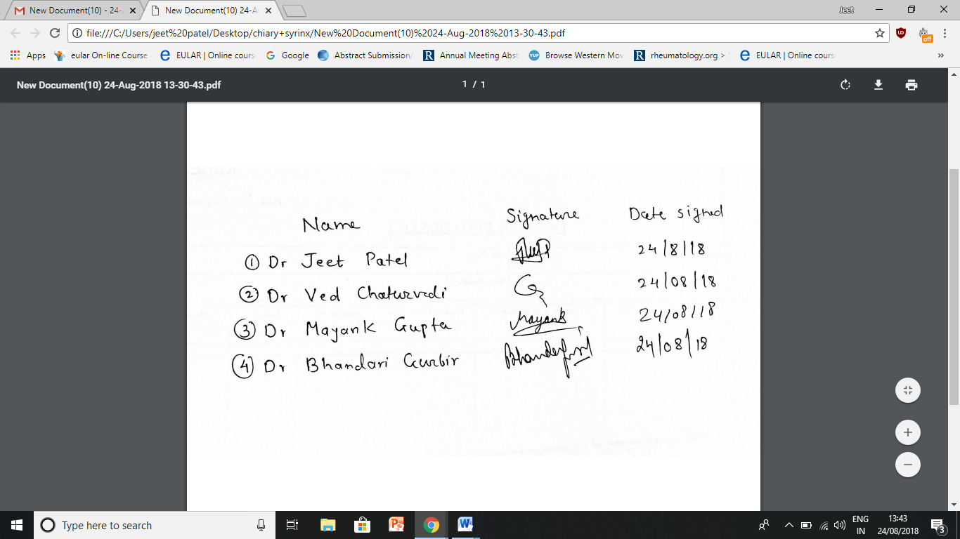

Checklist (to be tick marked, as applicable)

**Manuscript Title: Polyarticular charcot: a rare case report and a literature review in Indian context**

Checklist

**Covering letter**

**√**Signed by all contributors

* Previous publication / presentations mentioned – No with your journal

**√**Source of funding mentioned

**√**Conflicts of interest disclosed

**Authors**

**√**Middle name initials provided

**√**Author for correspondence, with e-mail address provided

**√**Number of contributors restricted as per the instructions

**√**Identity not revealed in paper except title page (e.g. name of the institute in material and methods, citing previous study as ‘our study’, names on figure labels, name of institute in photographs, etc.)

**Presentation and format**

**√**Double spacing

**√**Margins 2.5 cm from all four sides

**√**Title page contains all the desired information (vide supra)

**√**Running title provided (not more than 50 characters)

**√**Abstract page contains the full title of the manuscript

**√**Abstract provided (not more than 150 words)

* Structured abstract provided for an original article

**√**Key words provided (three or more)

**√**Introduction of 75-100 words

**√**Headings in title case (not ALL CAPITALS, not underlined)

**√**References cited in superscript in the text without brackets

**√**References according to the journal’s instructions.

**Language and grammar**

**√**Uniformly British English

**√**Abbreviations spelt out in full for the first time

**√**Numerals from 1 to 10 spelt out

**√**Numerals at the beginning of the sentence spelt out

**Tables and figures**

**√**No repetition of data in tables/graphs and in text

**√**Actual numbers from which graphs drawn, provided

**√**Figures necessary and of good quality (colour)

**√**Table and figure numbers in Arabic letters (not Roman)

**√**Figure legends provided (not more than 40 words)

**√**Patients’ privacy maintained (if not, written permission enclosed)

* Credit note for borrowed figures/tables provided

**Type of article**: Brief Report

Title Page

**Title of the article**: **Polyarticular charcot: a rare case report and a literature review in Indian context**

**Running title**: **Syrinx and Charcot arthropathy**

**Contributors**

1. **First Author**: Dr Jeet Patel*, Fellow in Training in Rheumatology and clinical immunology at Sir Ganga Ram Hospital, New Delhi, India.

* Currently working as consultant Rheumatologist at Arthritis Rheumatology Clinic, Vadodara, Gujarat

1. **Second Author**: Dr Ved Chaturvedi, senior consultant in Department of Rheumatology and clinical immunology at Sir Ganga Ram Hospital, New Delhi, India.
2. **Third Author**: Dr Mayank Gupta, Fellow in Training in Rheumatology and clinical immunology at Sir Ganga Ram Hospital, New Delhi, India.
3. **Fourth Author**: Dr Gurbir Bhandari**, Fellow in Training in Rheumatology and clinical immunology at Sir Ganga Ram Hospital, New Delhi, India.

* **\*\*** Currently working as consultant Rheumatologist at Adesh institute of medical science, Bhatinda, Punjab

Department(s) and institution(s) of all authors: Sir Ganga Ram Hospital, New Delhi.

* Corresponding Author: Dr Jeet Patel,

Mail I.D - [jeet5patel5@gmail.com](mailto:jeet5patel5@gmail.com), phone no: +91-9821808588,

* Postal address- Arthritis Rheumatology Clinic, 202, shyam arena, 14 A, B, sampatrao colony, Vadodara, Gujarat

Total number of pages: 13

Total number of figures: 04

Total numbers of tablesw: 02

Word counts:

for abstract: 193

for the text: 1987

Source(s) of support: NIl

Conflicting Interest (If present, give more details): Nil.

Acknowledgement (if any): Nil

Contribution Details (to be ticked marked as applicable):

|  |  |  |  |  |
| --- | --- | --- | --- | --- |
|  | Contributor 1 | Contributor 2 | Contributor 3 | Contributor 4 |
| Concepts | **√** | **√** |  |  |
| Design | **√** |  | **√** |  |
| Definition of intellectual content |  | **√** |  | **√** |
| Literature search |  |  | **√** | **√** |
| Clinical studies |  |  |  |  |
| Experimental studies |  |  |  |  |
| Data acquisition | **√** |  | **√** |  |
| Data analysis |  |  |  |  |
| Statistical analysis |  |  |  |  |
| Manuscript preparation | **√** |  | **√** | **√** |
| Manuscript editing |  | **√** |  |  |
| Manuscript review |  | **√** |  | **√** |
| Guarantor | **√** |  |  |  |