**Supplementary file**

Supplementary Tables:

Table 1: Spearman correlation of demographic, clinical and inflammatory parameters in systemic lupus erythematosus patients

|  |  |  |  |  |  |  |  |  |  |  |  |  |
| --- | --- | --- | --- | --- | --- | --- | --- | --- | --- | --- | --- | --- |
| Variables | Age | Gender | DOI | TLC | NLR | ESR | CRP | C3 | Immunosuppressants/ DMARDs | Steroids | Biologics | SLEDAI |
| Age | 1.00 | -0.03 | 0.41** | -0.06 | 0.08 | 0.12 | 0.07 | 0.09 | -0.24** | -0.06 | -0.04 | -0.27** |
| Gender |  | 1.00 | 0.06 | -0.06 | -0.07 | 0.06 | -0.06 | -0.04 | -0.08 | -0.07 | 0.06 | -0.23* |
| DOI |  |  | 1.00 | -0.11 | -0.04 | 0.10 | 0.00 | 0.09 | -0.29** | -0.01 | 0.17 | -0.10 |
| TLC |  |  |  | 1.00 | 0.26** | -0.21* | 0.28** | 0.24** | 0.04 | -0.08 | 0.08 | 0.19* |
| NLR |  |  |  |  | 1.00 | 0.03 | 0.31** | 0.02 | 0.22* | 0.29** | 0.12 | 0.07 |
| ESR |  |  |  |  |  | 1.00 | 0.24** | 0.02 | -0.02 | 0.03 | -0.08 | 0.08 |
| CRP |  |  |  |  |  |  | 1.00 | 0.13 | 0.05 | 0.06 | -0.20* | -0.03 |
| C3 |  |  |  |  |  |  |  | 1.00 | -0.11 | -0.36** | -0.10 | 0.02 |
| Immunosuppressants/ DMARDs |  |  |  |  |  |  |  |  | 1.00 | 0.09 | -0.05 | 0.08 |
| Steroids |  |  |  |  |  |  |  |  |  | 1.00 | 0.20* | 0.03 |
| Biologics |  |  |  |  |  |  |  |  |  |  | 1.00 | 0.04 |
| SLEDAI |  |  |  |  |  |  |  |  |  |  |  | 1.00 |

**. Correlation is significant at the 0.01 level (2-tailed).

*. Correlation is significant at the 0.05 level (2-tailed).

Abbreviations: DOI: duration of illness, TLC: total leucocyte count, NLR: neutrophil to lymphocyte ratio, ESR: erythrocyte sedimentation rate, CRP: C-reactive protein, C3: complement factor 3, DMARDs: disease modifying anti-rheumatic drugs, and SLEDAI: systemic lupus erythematosus disease activity index-2K score

Table 2: Spearman correlation of inflammatory parameters classified on SLEDAI disease activity score in systemic lupus erythematosus patients

|  |  |  |  |  |  |
| --- | --- | --- | --- | --- | --- |
| Variables | SLEDAI (1) | NLR (1) | ESR (1) | CRP (1) | C3 (1) |
| SLEDAI (1) | 1.00 | -0.33 | 0.13 | -0.17 | 0.14 |
| NLR (1) |  | 1.00 | 0.07 | 0.54** | 0.05 |
| ESR (1) |  |  | 1.00 | 0.09 | -0.03 |
| CRP (1) |  |  |  | 1.00 | 0.32 |
| C3 (1) |  |  |  |  | 1.00 |
|  | SLEDAI (2) | NLR (2) | ESR (2) | CRP (2) | C3 (2) |
| SLEDAI (2) | 1.00 | 0.04 | 0.05 | -0.07 | -0.02 |
| NLR (2) |  | 1.00 | -0.06 | 0.01 | 0.26 |
| ESR (2) |  |  | 1.00 | 0.11 | -0.04 |
| CRP (2) |  |  |  | 1.00 | 0.33 |
| C3 (2) |  |  |  |  | 1.00 |
|  | SLEDAI (3) | NLR (3) | ESR (3) | CRP (3) | C3 (3) |
| SLEDAI (3) | 1.00 | 0.08 | -0.01 | 0.11 | 0.12 |
| NLR (3) |  | 1.00 | 0.03 | 0.35** | -0.12 |
| ESR (3) |  |  | 1.00 | 0.33* | 0.05 |
| CRP (3) |  |  |  | 1.00 | 0.00 |
| C3 (3) |  |  |  |  | 1.00 |

**. Correlation is significant at the 0.01 level (2-tailed).

*. Correlation is significant at the 0.05 level (2-tailed).

Abbreviations: SLEDAI: systemic lupus erythematosus disease activity index-2K score, NLR: neutrophil to lymphocyte ratio, ESR: erythrocyte sedimentation rate, CRP: C-reactive protein and C3: complement factor 3.

(1) Variables classified on SLEDAI mild (4-8) disease activity score, (2) Variables classified on SLEDAI moderate (9-11) disease activity score, and (3) Variables classified on SLEDAI severe (≥12) disease activity score

Table 3: Spearman correlation of inflammatory parameters classified on NLR sub-groups in systemic lupus erythematosus patients

|  |  |  |  |  |  |
| --- | --- | --- | --- | --- | --- |
| Variables | NLR (1) | ESR (1) | CRP (1) | C3 (1) | SLEDAI (1) |
| NLR (1) | 1.00 | -0.18 | -0.03 | 0.30* | 0.13 |
| ESR (1) |  | 1.00 | 0.31* | -0.20 | 0.02 |
| CRP (1) |  |  | 1.00 | 0.11 | -0.15 |
| C3 (1) |  |  |  | 1.00 | 0.14 |
| SLEDAI (1) |  |  |  |  | 1.00 |
|  | NLR (2) | ESR (2) | CRP (2) | C3 (2) | SLEDAI (2) |
| NLR (2) | 1.00 | 0.06 | 0.18 | 0.09 | -0.37* |
| ESR (2) |  | 1.00 | 0.22 | 0.20 | 0.08 |
| CRP (2) |  |  | 1.00 | 0.19 | 0.01 |
| C3 (2) |  |  |  | 1.00 | 0.01 |
| SLEDAI (2) |  |  |  |  | 1.00 |
|  | NLR (3) | ESR (3) | CRP (3) | C3 (3) | SLEDAI (3) |
| NLR (3) | 1.00 | 0.23 | 0.04 | -0.14 | -0.26 |
| ESR (3) |  | 1.00 | 0.14 | -0.03 | 0.30 |
| CRP (3) |  |  | 1.00 | 0.14 | 0.09 |
| C3 (3) |  |  |  | 1.00 | -0.12 |
| SLEDAI (3) |  |  |  |  | 1.00 |

*. Correlation is significant at the 0.05 level (2-tailed). Abbreviations: NLR: neutrophil to lymphocyte ratio, ESR: erythrocyte sedimentation rate, CRP: C-reactive protein, C3: complement factor 3, and SLEDAI: systemic lupus erythematosus disease activity index-2K score.

(1) Variables classified on NLR ≤2 values, (2) Variables classified on NLR >2–4 values and (3) Variables classified on NLR >4 values.

Supplementary figure:

Figure 1:

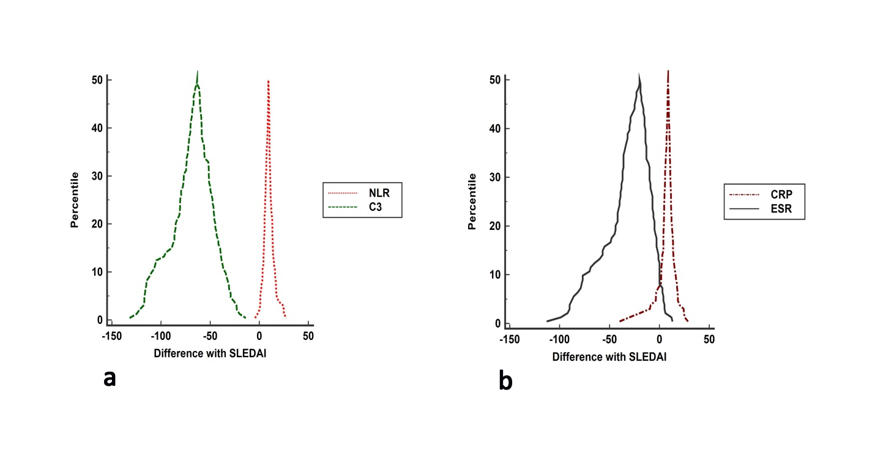

Mountain plot for difference and agreement among neutrophil-to-lymphocyte ratio (NLR), erythrocyte sedimentation rate (ESR), C-reactive protein (CRP) and Complement factor 3 (C3) with systemic lupus erythematosus disease activity index-2K (SLEDAI) in systemic lupus erythematosus patients. CRP had least bias compared to NLR, ESR and C3.

Figure 2:

C:\Users\Anupamma\Desktop\SLE-NLR study-Lupus submission\Diagrams-SLE-NLR study\Supplementary Figure 2-ROC.tif

Receiver operating characteristic (ROC) plot to evaluate the discriminatory ability of neutrophil-to-lymphocyte ratio (NLR), erythrocyte sedimentation rate (ESR) and complement factor 3 (C3) in classifying severe disease activity in systemic erythematosus (SLE) patients. NLR, ESR and C3 had no discriminatory ability to classify severe disease activity patients.