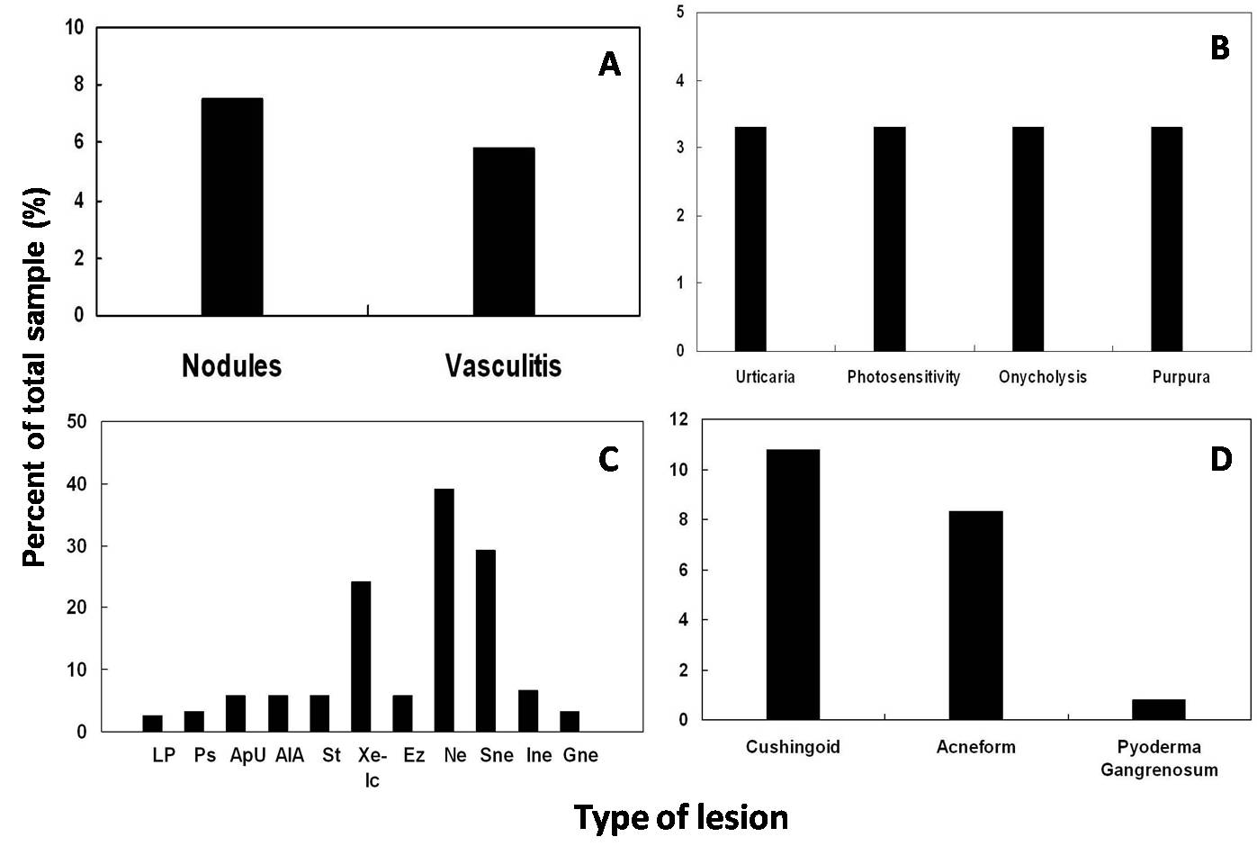

Figure 2 Characteristics cutaneous manifestations A. Specific lesions, B. Non-specific lesions, C. Miscellaneous lesions, and D. Therapy induced lesions.
Abbreviations: LP - lichen planus, Ps - Psoriasis, ApU - aphthous ulcer, AlA - alopecia areata, St - striae, Xe – xerosis, Ic - icthyosis, Ez - Eczema, Ne - nevi, SNe - small nevi, INe - intermediate nevi, GNe - giant nevi.

