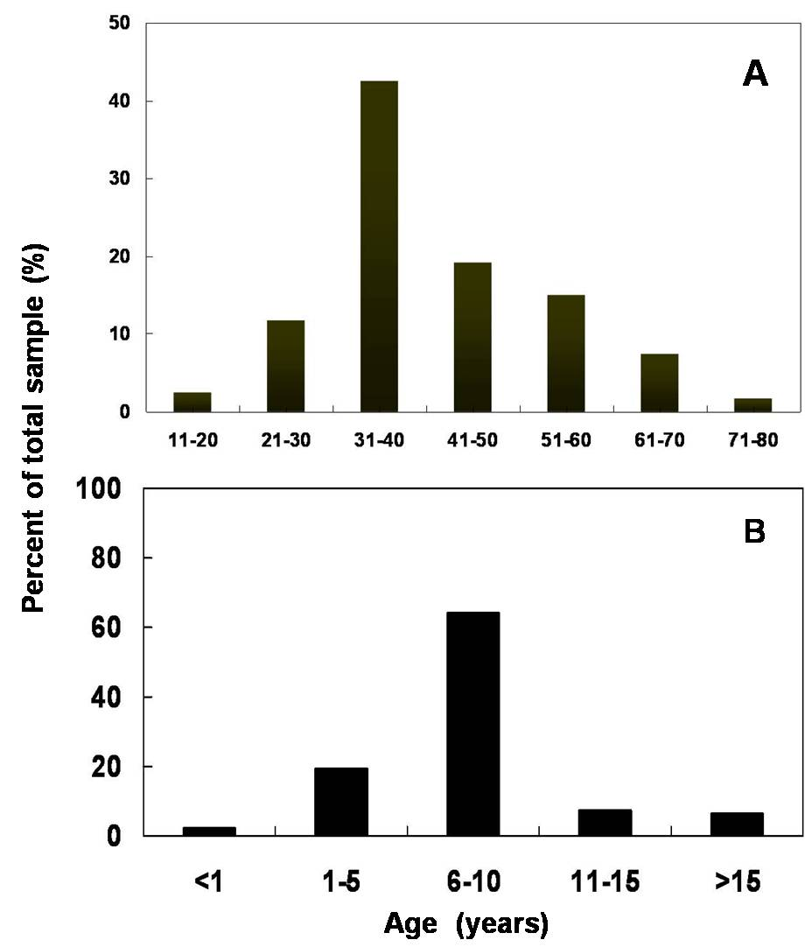

Figure 1 Subject demographic characteristics: A. Age distribution, B. Disease duration

