Quantification of inflammation in inflammatory eye diseases

Dr. Padmamalini Mahendradas, Dr. Anjani Khanna,
Dr. Ankush Kawali, Dr. Rohit Shetty

Narayana Nethralaya and Post Graduate Institute Of Ophthalmology, Bangalore.

Quantification of inflammation can be done by measuring the cells and flare present in the anterior chamber and vitreous humour. These gradings are universally accepted and practiced all over the world. Disadvantage of these methods are subjective grading system. It can be overcome by measuring the cells and flare by laser flaremetry. But it is not available in all parts of the world. Our article highlights the different methods and various parameters clinically used to asses the inflammation along with role of various imaging techniques in the diagnosis and monitoring the response to treatment in ocular inflammatory diseases.
The eye is a unique organ which provides an opportunity to visualize the real time pathological or inflammatory changes occurring in the body by direct examination. The changes occurring can be quantified in different ocular inflammations. The eye is affected by different inflammatory conditions, categorized based on layers involved as uveitis(uveal tract), scleritis (Sclera) Reitinits (Retina), Vitritis(Vitreous humor) etc. It is further characterized by the finding as granulomatous, non-granulomatous depending on the probabale pathological characteristics as well as depending upon the etiological and the duration of disease as acute and chronic inflammation. The greatest advantage in eye is with an exception of few areas majority of the inflamed areas can be visualized by direct visual examination. Simple non-invasive imaging modalities like ultrasound and other modalities can assist in accessing the remaining area.
Damage to an organ in inflammatory conditions depends upon the quantity of inflammation, type of inflammation proportional to the total duration of inflammation. While prescribing immune-suppressants either systemic or topical under normal circumstances a conscious decision about the quantum of immune suppression and the duration of therapy will be based on the approximated estimation of inflammation. Thus quantifying inflammation essentially guides the clinician in deciding the therapy and duration of therapy. In this review we briefly update different methods which are currently utilized in assessing inflammatory disease activity, which guide in management of eyes with varied inflammatory conditions.

Uveitis

In patients with uveitis, presence of various clinical indicators can give clues to possible etiology of the disease and also about the chronicity and severity of the disease. Meticulous ocular examination using a slit lamp and indirect ophthalmoscopy along with modern imaging techniques can grade or quantify severity of the inflammation.

Clinical features of Uveitis
Ocular signs of a systemic inflammatory disease may be reflected in every ocular structure, right from eyelids to the optic nerve. Presence of poliosis or vitiligo on eyelids may point towards Vogt Koyanagi Harada disease. Conjunctival granulomas (Millet-seed sign) may suggest Sarcoidosis. Corneal endothelium may show keratic precipitates which may tell us whether the inflammation is of granulomatous type or non granulomatous. Inflammation leads to increase in vascular permeability and disruption of blood aqueous barrier causing flare in the anterior chamber and also chemotaxis which is responsible for the presence of inflammatory cells in the anterior chamber and vitreous reaction. These cells can be clinically graded and quantified.
To standardize the uniformity in reporting the gradation of clinical finding across clinician standardized nomenclature are defined. Most commonly used among them was developed by the Standardization of Uveitis nomenclature (SUN)¹ working group for grading inflammation in anterior chamber and vitreous. Observer can assess cells and flare in the anterior chamber using a slit lamp beam of 1X1 mm in height and width when thrown at an angle of 45-60°. Based on the finding can categorize the finding as mild to severe grade. (Table 1)
Table 1. The SUN Working Group Grading system for Anterior Chamber Cells.¹
Grade | Cells in Field
0 | <1
0.5+ | 1–5
1+ | 6–15
2+ | 16–25
3+ | 26–50
4+ | >50

Table 2. The SUN Working Group Grading system for Anterior Chamber flare¹
Grade | Description
0 | None
1+ | Faint
2+ | Moderate (iris and lens details clear)
3+ | Marked (iris and lens details hazy)
4+ | Intense (fibrin or plastic aqueous)

The greatest advantages of a standard system are the ability to translate the findings across the clinician all over the world; but the present system is limited by its subjective nature and hence a limited reproducibility.
Other indicators of inflammation which are not included in grading as well not scored separately in the present system are nodules, vascularization of iris or angle, trabeculitis, anterior and posterior synechiae, atrophy of iris and heterochromia.
When the inflammation occurs in intermediate segment of the eye it leads to vitritis which is graded depending upon the number of vitreous cells and haze according to the following classification-Table2/3
Table 3. National Institutes of Health (NIH) grading system for vitreous cells. ²
Grade | Number of vitreous cells
0 | No cells
0.5+ | 1-10
1+ | 11-20
2+ | 20-30
3+ | 30-100
4+ | >100

Table 4. National Institutes of Health (NIH) grading system for vitreous haze.²
Grade | Amount of vitreous flare/haze
0 | No flare
1+ | Clear optic disc and vessels Hazy nerve fibre layer
2+ | Hazy optic disc and vessels
3+ | Optic disc visible
4+ | Optic disc not visible

Figure.1 Grading of vitreous haze.²
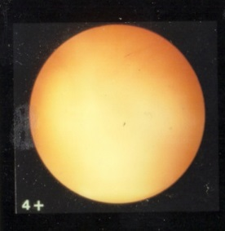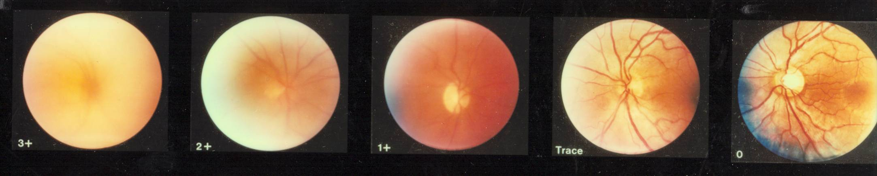
The findings like vitreous exudates in the form of snow balls tell us about the chronicity of the disease. Larger snow ball may indicate granulomatous nature of the inflammation. Chronic intermediate uveitis can also cause cyclitic membrane formation, secondary ciliary body detachment leading to hypotony or prephthisical stage. Unfortunately these signs cannot be assessed clinically nor graded.
Posterior segment inflammation can lead to cystoid macular edema, retinal or choroidal infiltrates, inflammatory sheathing of vessels, exudative, tractional or rhegmatgenous retinal detachment, retinal pigment epithelium (RPE) hypertrophy or atrophy, edema and secondary atrophy of retina, choroid and optic nerve. The sequelae can also include preretinal/subretinal fibrosis and choroidal neovascularization. These changes are currently consider to be inconsistent that grading of inflammation based on these findings is not possible. Imaging for vasculitis, cystoids macular edema or chorioretinal infiltration may help documenting improvement or worsening of inflammation.
Scleritis, sclerouveitis-
Various autoimmune diseases are associated with involvement of the sclera alone or with corneal involvement or intraocular inflammation. McClusky scleritis scoring system³ assesses the severity and gives guidelines for appropriate treatment of various grades of scleritis. But a system of classification that takes into account the corneal and intraocular involvement and prognosticates various stages of disease is lacking.

Table 5a. ScleritisScoring system- Mc Clusky.³
PARAMETER |  | Score
Laterality  Tenderness  Nodules  Vision loss  Scleral necrosis  A C reaction  IOP >22 mm Hg  Vitreous cells  RD present | Unilateral  Bilateral  Single  Multiple  < 2 lines  Absent  Present  Progressive  Grade 0-4 | 1  3  0-4  2  4  1  0  2  4  1  0-4  4

Table 5b. Scleritis Scoring system (score based treatment) - Mc Clusky.³
Score | Treatment Regimen
MILD (score < 9) | Oral/Pulsed steroids
MODERATE (score 9-12) | Azathioprine
SEVERE (score >13) | Intravenous Methyl Prednisololone (IVMP)  Cyclophosphamide, Cyclosporine
Improvement | Score < by 2
Resolution | Score < by 4
Though this system takes into account clinical features such as the area of inflammation, pain, and associated anterior chamber inflammation, it does not specifically address the corneal involvement and degree or severity of inflammation. It is more useful in following the disease course than assessing severity of inflammation at a single visit. To overcome the above limitations another system was proposed by Sen et al proposed a system based on photographic standards for grading the severity of inflammation. Severity of scleritis is graded from 0-4+ based on standard photographs after instillation of 10% Phenylephrine for 15-20 minutes. They found a good inter-observer agreement during the grading of scleritis by this system between various examiners and propose it to be easy and clinically applicable method for grading of severity of inflammation in
scleritis.⁴

Table 6. Scleritis Grading ( Following 10% Phenylephrine application) Standardized grading system for scleritis- Senet al.⁴
Score | Grade | Clinical Description
0 | None | Complete blanching after 10% phenylephrine
+0.5 | Minimal | Localised pink appearance of the sclera around minimally dilated deep episcleral vessels
+ 1 | Mild | Diffuse pink appearance of the sclera around midly dilated deep episcleral vessels
+2 | Moderate | Purplish pink appearance of the sclera with significantly tortuous and engorged deep episcleral vessels
+3 | Severe | Diffuse redness of the sclera, the details of superficial and deep episcleral vessels can’t be observed
+4 | Necrotizing | Diffuse redness of the sclera with sclera thinning and uveal show

Ancillary investigations
In addition to clinical observation ancillary investigations can provide diagnostic clues and also help in monitoring response to treatment. Following investigations may aid in assessing inflammatory disease process.
Laser Flare photometry
Laser flare/cell photometer (LFP) comprises of a photomultiplier-photodetector which detects back scattered light that is reflected off from proteins in the anterior chamber (flare) and cells in the anterior chamber. This is a quantitative method of measurement of intraocular inflammation and more objective and hence consider superior to slit lamp grading systems in diagnosing subclinical inflammation, monitoring response to treatment and detecting disease relapses.⁵ Gonzales et al. reported an inverse relationship between LFP flare and visual acuity in patients with uveitis.⁶ A strong correlation was also found between LFP flare and complications such as posterior synechiae and macular edema while no relationship was found between complications and anterior chamber cell or flare scores at the slit-lamp.⁶
Normal values for aqueous flare intensity have been found to be in the range of 2.9–3.9 ph/ms in healthy individuals between 20 and 40 years of age.⁷⁻⁹ Flare values have been found to increase slightly with age, reaching 5.0–6.5 ph/ms between 70 and 80 years of age.⁷ due to a breakdown of the blood–aqueous barrier, changes in protein composition of the aqueous humor or cataract development with age.⁹
In patients with uveitis LFP has proven to be a guide to starting and monitoring treatment and also in detecting relapses. In a study of 44 patients presenting with acute episode of HLA B27 associated anterior uveitis, mean initial flare was 160 ± 22 ph/ms (range: 11–787 ph/ms). After treatment with a standard therapeutic regimen, 50 and 90% flare reduced after 2 and 8 days, respectively. In 15 out of the 44 patients enrolled, an additional periocular corticosteroid injection was needed because of insufficient flare decrease (less than 30% of initial flare) or flare increase after 48 hrs. A flare level under 8 ph/ms was accepted as the resolution (end of an episode).¹⁰ Hence meticulous adjustment of therapy in patients with HLA-B27-associated uveitis can be made with the help of LFP. Similarly LFP has is useful in monitoring response to treatment and titrating the treatment in diseases like Behcet’s disease, VKH, Fuchs’ uveitis and uveitis associated with JIA.¹¹⁻¹⁸ This method though useful is not universally available and hence one may have to rely on clinical grading.

Ultrasound Biomicroscopy (UBM)
UBM is a high frequency (35-100 MHz) ultrasound which is used to assess inflammation in anterior segment of the eye. It is useful to study hidden structures such as cilliary body, angle, artificial lens haptic position and peripheral choroid, pars plana which are difficult to be visualized by direct examination and it is also useful to measure anterior sclera thickness. It can be used to study anatomical integrity of anterior segment (iris and lens) when cornea is opaque or when there is total hyphema.
Fundus photography
Fundus pictures are taken at baseline documentation and useful to monitor response to given treatment for retinitis, choroiditis, vasculitis and other inflammatory changes. Stereoscopic pictures are more useful to document macular edema, optic nerve head edema, Choroidal neovascular membrane (CNVM), exudative retinal detachment and large choroidal granuloma. These are used to document response to treatment and monitor media clarity in patients with vitritis. Wide field retinal imaging is used to document the peripheral retinal changes in uveitis.

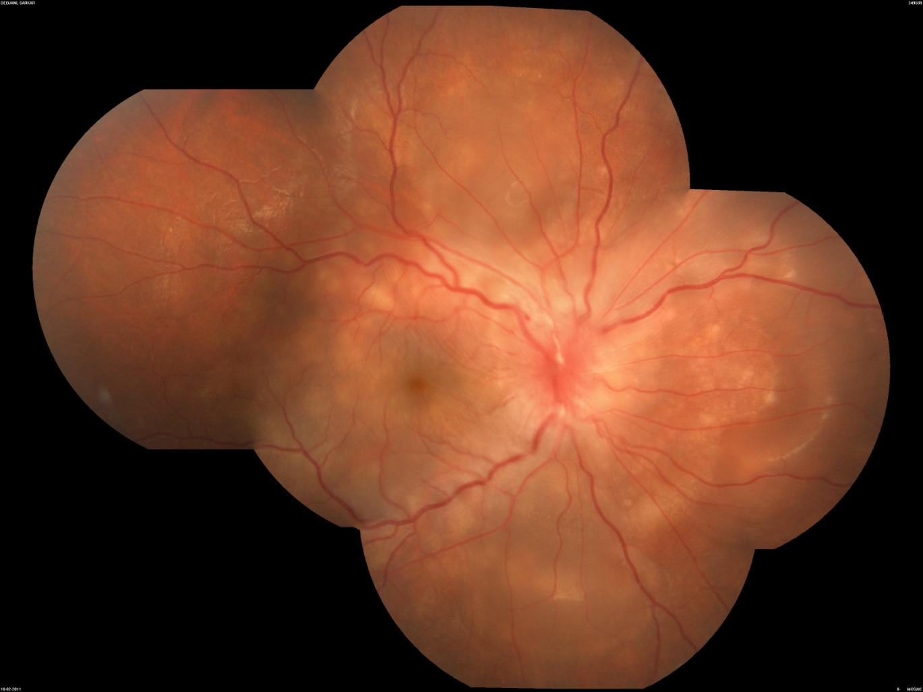
Figure 2:Montage colour fundus photograph of the right eye showed hyperemic disc with multiple serous retinal detachment in the right eye in a case of Vogt- Koyanagi- Harada disease

Ultrasonography (B scan)-
Ultrasound has an important role in the evaluation of uveitic conditions especially in which the media haze precludes adequate visualization of posterior segment. Vitritis, exudative membranes in the vitreous, posterior vitreous detachment (PVD), subretinal exudates or mass lesions , retinochoroidal layer or posterior scleral thickening, severe macular edema with detachment, exudative, tractional or rhegmatogenous retinal detachment, choroidal detachment are all the features of posterior uveitis which can be documented on B-scan. Sometimes it can also help in differentiating exudative retinal detachment (inflammatory) from rhegmatogenous (non inflammatory).
In patients with anterior scleritis, the clinical signs are visible like episcleral and sclera congestion and tenderness of sclera. But in posterior scleritis especially with no or minimal anterior segment findings the diagnosis and assessment can be made by ultrasound in the presence of diffuse/nodular retinochoroidal thickening, episcleral infiltration/edema, distension of Subtenon’s space causing the “T” sign and also associated choroidal, ciliary body or exudative retinal detachments.
B-scan also differentiate active and old vitreous inflammation. In a patient with complete PVD, dot echoes in subvitreal space may signify active inflammation. Inflammatory conditions of choroid like Vogt-Koyanagi Harada syndrome, Sympathetic ophthalmitis, uveal effusion syndrome and masquerades like uveal lymphoid infiltration are associated with diffuse choroidal thickening , serous retinal detachment and vitritis which can be monitored on serial ultrasounds after treatment.
Quantification of the inflammation is possible in case of posterior scleritis by measuring thickness of posterior sclera and vitreous inflammation can be graded as mild, moderate and severe.

Autofluorescence
Fundus autofluorescence is a rapid non contact, non invasive method to evaluate RPE function. The byproducts of RPE phagocytosis of photoreceptor outer segments consist of retinoids, fatty acids, proteins and lipofuscin. Lipofuscin in turn accumulates and causes autofluorescence, hence this is a measure of metabolic activity of RPE cells. In inflammatory conditions, the metabolism of RPE cells is altered and hence autofluoresence is altered depending upon the disease activity.
In fundus autofluorescence, areas of hyperautofluorescence suggest active inflammation and hypoautofluorescence suggest inactive or healed lesions. Mixed autofluorescence ( hypo with hyper autofluorescence suggest healing inflammation.
Gupta et al reported four stages of disease activity in serpiginous like choroiditis based on autofluorescence. Stage 1: with active edge shows an area of hyperautofluorescence at the borders of active edge. As the disease starts healing, the hyperautofluorescence is replaced with hypoautofluorescence; Stage 2: disease shows healing lesions with mixed autofluorescence that are predominantly hyperautofluorescent; Stage 3: the lesions that are now progressively healing show mixed autofluorescence and are predominantly hypofluorescent; and Stage 4: as the lesions become totally healed with scar, they show total hypofluorescence.¹⁹
Vasconcelos-Santos et al described the FAF features of VKH. They found areas of hypoautoflurescence which corresponded to areas of peripapillary atrophy and atrophic scars signifying atrophy of RPE and outer retina. Also the pigmented scars with thickening of RPE or BM layer were hypoautofluorescent. Clinically normal looking retina was found to be hyperautofluorescent signifying subclnical inflammation. Hyperautofluorescence was also seen in areas of cystoid macular edema. Sunset glow fundus, disciform scars and sectoral chorioretinal atrophic areas showed similar autoflouresencence as the background.²⁰
Wide field Fundus autofluorescence can be used to detect peripheral changes otherwise missed on routine fundus imaging.

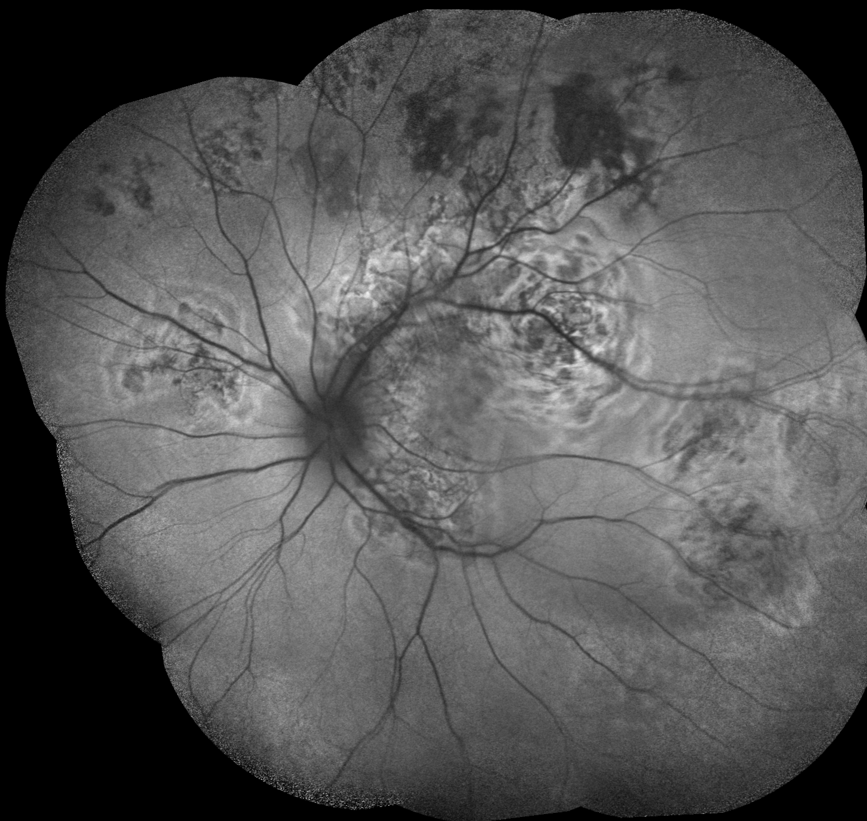
Figure 3: Montage autofluorescence imaging showed areas of hyperautofluorescence corresponding to the areas of active choroiditis with hypoautofluorescence lesions suggestive of healed lesions in a case of serpiginous like choroiditis.
Fundus Fluorescein Angiography (FFA)
FFA is useful in identifying vascular leaks in patients with vasculitis and distinguishing active from inactive disease which is important while monitoring response to treatment and checking for relapses. It also detects subclinical retinal capillary involvement that can be missed on clinical examination. Associated conditions like CME, CNVM, vascular occlusions, areas of capillary non-perfusion and neovascularization can also detected and studied better with the help of FFA. Previously CME was graded on the basis of FFA. One classification given by Miyake classified CME as :Grade 0: no sign of fluorescein leakage; Grade I: slight fluorescein leakage into cystic spaces but not enough to enclose the entire fovea centralis; Grade II: complete circular accumulation of the fluorescein in the cysticspace but its diameter is smaller than 2 mm; and Grade III: the circular accumulation of fluorescein is larger than 2.0 mm in diameter.²¹
Another classification by Yannuzzi classifies CME slightly differently as Grade 0: no perifoveal hyperfluorescence; Grade 1: incomplete perifoveal hyperfluorescence; Grade 2: mild 360 degree hyperfluorescence; Grade 3: moderate hyperfluorescent area being approximately 1 disc diameter across; and Grade 4: severe 360° hyperfluorescence with the hyperfluorescent area being approximately 1.5 disc diameter across.²²
OCT has by and large replaced FFA as the investigation of choice for macular edema. According to MUST trial Research group OCT was able to diagnose edema in 90.4% of cases compared to FA that gave useful information only in 77%. Nevertheless, FFA is a useful adjunct to OCT in cases where macular leakage is the determining factor for treatment.²³
Though FFA is not the investigation of choice for choroidal diseases, certain features on FFA like initial hypofluorescent dots or areas of delayed choroidal filling with late pooling of dye in subretinal space with disc hyperfluorescence characterize VKH and sympathetic ophthalmitis.

Indocyanine green angiography (ICGA)
ICG having a bigger molecule then fluorescein doesn’t leak from choroidal vessels making it an investigation of choice for choroidal pathologies. Choroidal inflammation has been classified based on ICG as 1) Inflammation of choriocapillaris i.e. choriocapillaritis e.g diseases like Multiple Evanescent White Dot Syndromes (MEWDS), Acute Posterior Multifocal Placoid Pigment Epitheliopathy (APMPPE), Multifocal choroiditis, Serpiginous choroiditis which predominantly effect choriocapillaris and 2) Inflammation of choroidal stroma- stromal choroiditis in diseases like VKH, Sympathetic ophthalmitis and Birdshot Chorioretinopathy.
ICGA can detect lesions not apparent clinically and even on FFA. It can show hypofluorescence or hyperfluorescence. Choroidal stromal infiltration or choriocapillaris non perfusion can lead to hypofluorescence with diffuse choroidal fluorescence in late phases. Hyperfluorescence can be caused by leakage from large inflamed choroidal vessels or late hyperfluorescent pin point leaks signifying granulomatous disease.
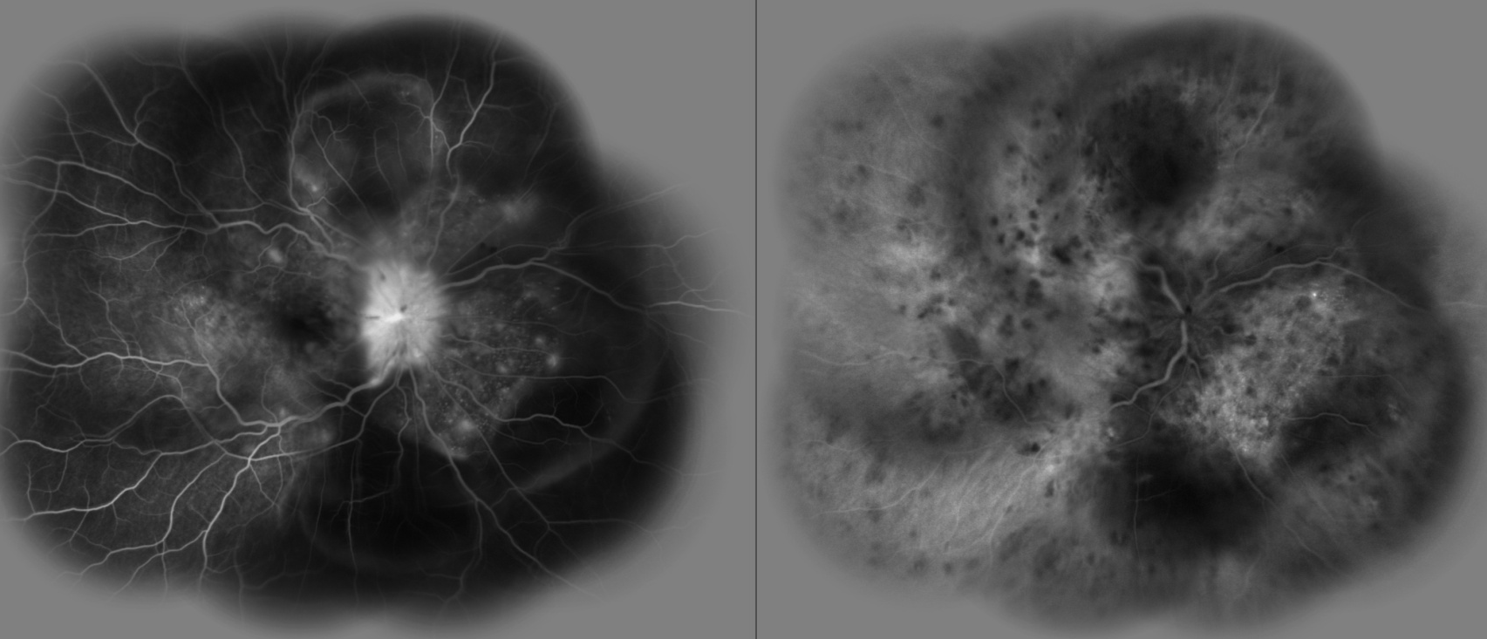
Figure 4 :Combined FFA & ICG imaging revealed disc hyperfluorescence with multiple pin point hyperfluorescence with late pooling of the eye in FFA with multiple hypofluorescence with staining and leakage of the choroidal vessels in the right eye in a case of Vogt- Koyanagi – Harada disease.
Optical coherence tomography (OCT) -
OCT is a useful tool for detecting inflammation and defining the location, extent and depth of a lesion helping in diagnosis and monitoring of treatment. Posterior vitreous cells can be documented on OCT so can macular edema which can be quantified and monitored after treatment. Associated features like vitreomacular traction (VMT), epiretinal membranes (ERM), serous detachments of retina (especially in VKH and Sympathetic ophthalmitis) can be detected and monitored.
Previously OCT could only show lesions closer to the vitreoretinal interface with greatest clarity due to the placement of focus at that interface. Then newer softwares with enhanced depth imaging shifted the focus to choroid to better delineate choroidal lesions. Recently softwares with combined depth imaging with focus both at choroidal and vitreoretinal surface have enabled better delineation and study of lesions placed anywhere in the retina or choroid.
This modality can measure central foveal thickness in micrometers and hence can quantify inflammation which is very essential to monitor inflammation.
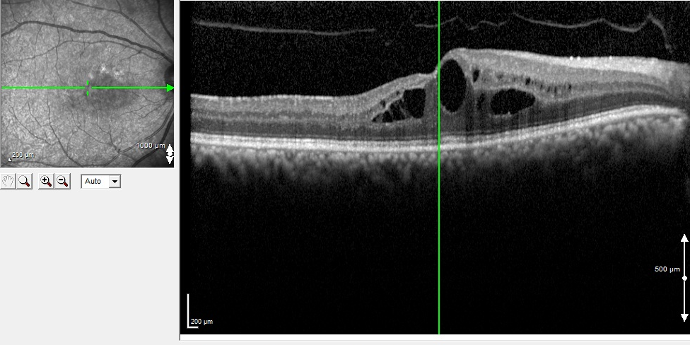
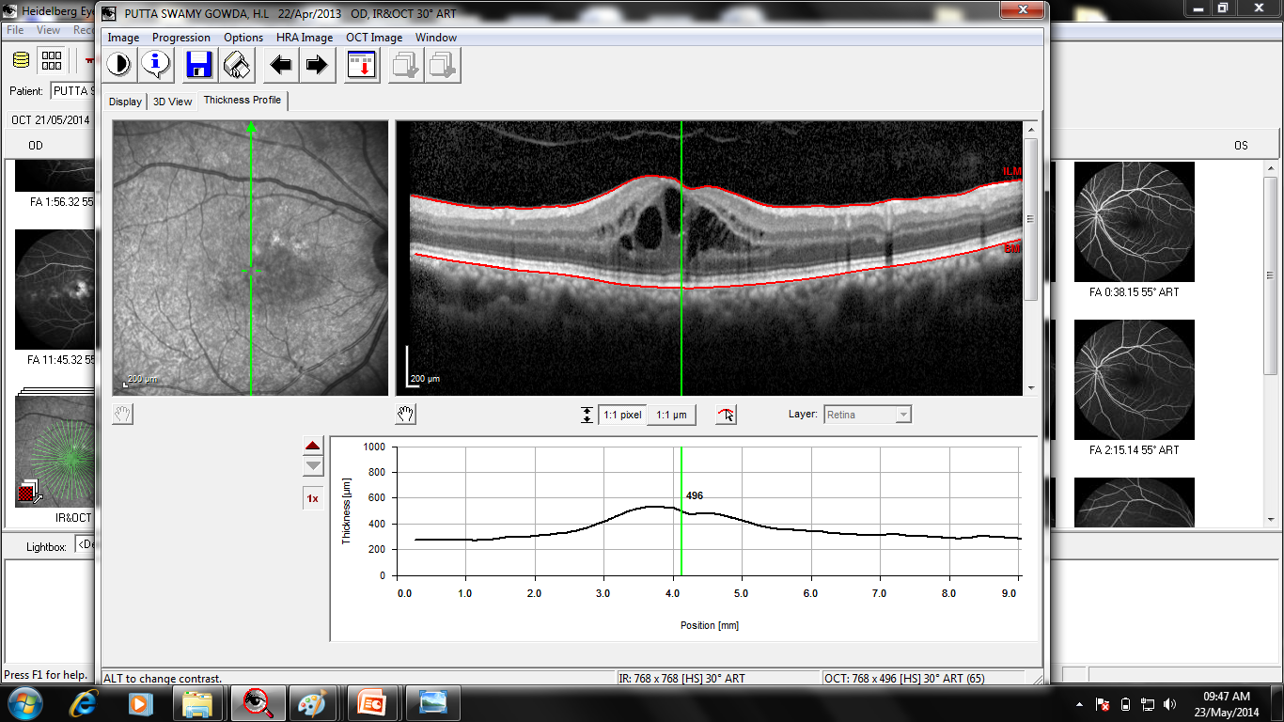
Figure 5 A :Optical coherence tomography horizontal line scan image revealed posterior vitreous detachment with hyporeflective cystic space suggestive of cystoids macular edema with central retinal thickness of 496 microns in the right eye .
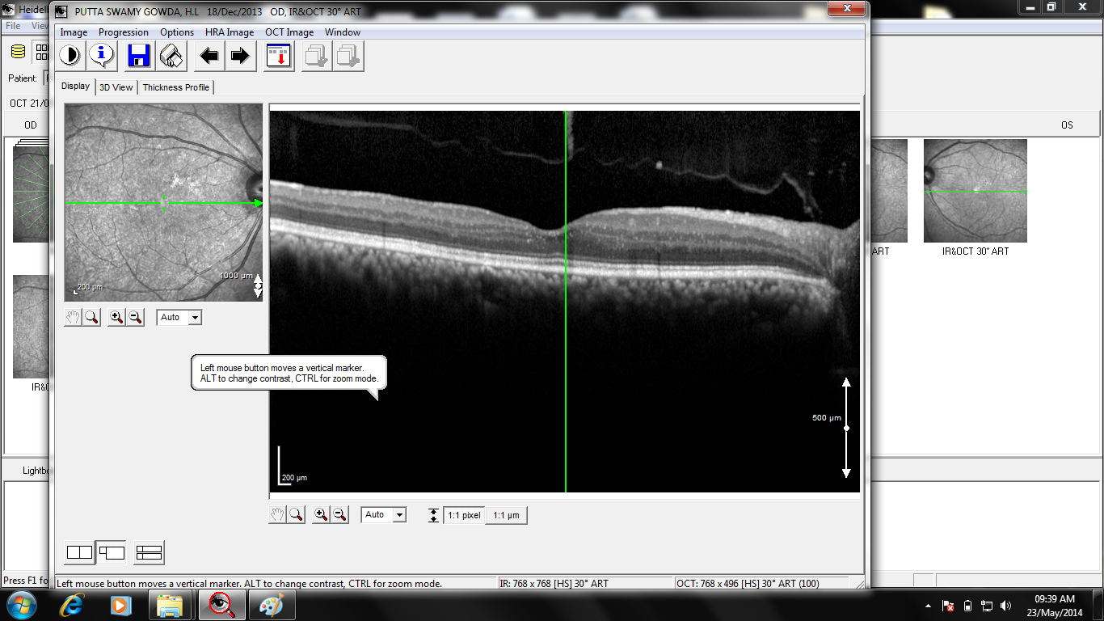
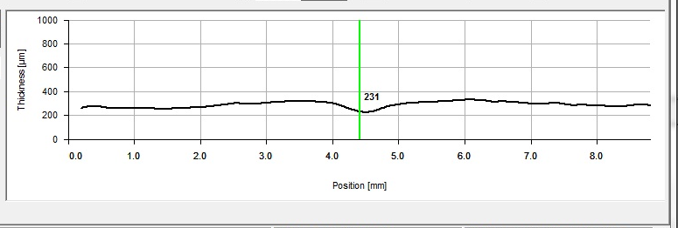
Figure 5 B : Horizontal line scan image of the right eye shows resolved

cystoids macular edema with central retinal thickness of 231 microns.

Cytokine estimation

Cytokines can be measured from the tears and ocular fluids in various

uveitis entities. IL-17 plays a major role in immune-mediated uveitis.²⁴

Yoshimura showed that IL-6 is elevated in the vitreous fluid of patients

with chronic uveitis. ²⁵

Conclusions
There are numerous pointers to inflammatory disease processes in the eye which can be detected clinically or with the help of investigations. A reproducible and universally acceptable system of grading of inflammation based on various clinical features and findings on imaging studies needs to be devised which can further help in early and correct diagnosis, appropriate treatment, titration of treatment, better monitoring the disease and early detection of relapses.

References :
- Jabs DA, Nussenblatt RB, Rosenbaum JT. Standardization of uveitis nomenclature (SUN) for reporting clinical data.-Results of the First International Workshop. Am J Ophthalmol. 2005;150:509–16.
- Nussenblatt RB, Palestine AG, Chan C, Roberge F. Standardization of vitreal inflammatory activityin intermediate and posterior uveitis. Ophthalmology. 1985; 92:467–471.
- McCluskey PJ, Wakefield D. Prediction of response to treatment in patients with scleritis using astandardized scoring system. Aust N Z J Ophthalmology. 1991; 19:211–215.
- H.NidaSen, Sangave A, Goldstein D A et al. A standardized grading system for scleritis. Ophthalmology. Apr 2011; 118(4): 768–771.
- Ni M, Bloom JN, Lele S, Sotelo-Avila C. A laboratory evaluation of the Kowa laser flare-cell meter for the study of uveitis. Graefes Arch ClinExpOphthalmol. 1992;230:547–51.

- Gonzales CA, Ladas JG, Davis JL, Feuer WJ, Holland GN. Relationships between laser flare photometry values and complications of uveitis. Arch. Ophthalmol.2001:119(12); 1763–69.
- Sawa M, Tsurimaki Y, Tsuru T, Shimizu H. New quantitative method to determine protein concentration and cell number in aqueous in vivo . Jpn. J. Ophthalmol.1988: 32(2);132–42.
- Onodera T, Gimbel HV, DeBroff BM. Aqueous flare and cell number in healthy eyes of Caucasians. Jpn. J. Ophthalmol.1993: 37(4);445–51.
- Guillén-Monterrubío OM, Hartikainen J, Taskinen K, Saari KM. Quantitative determination of aqueous flare and cells in healthy eyes. Acta Ophthalmol Scand.1997:75(1);58–62.
10)Herbort CP, Guex-Crosier Y, de Ancos E, Pittet N. Use of laser flare
photometry to assess and monitor inflammation in
uveitis. Ophthalmology 1997:104(1);64–71.
11)Tugal-Tutkun I, Cingü K, Kir N, Yeniad B, Urgancioglu M, Gül A.
Use of laser flare-cell photometry to quantify intraocular
inflammation in patients with Behçet uveitis.Graefes Arch. Clin.
Exp. Ophthalmol.2008: 246(8);1169–77.
- Yang P, Fang W, Huang X, Zhou H, Wang L, Jiang B. Alterations of aqueous flare and cells detected by laser flare-cell photometry in patients with Behcet’s disease. Int. Ophthalmol.2010: 30(5);485–89.
- Küchle M, Nguyen NX. Analysis of the blood–aqueous barrier by measurement of aqueous flare in 31 eyes with Fuchs’ heterochromic uveitis with and without secondary open-angle glaucoma. Klin. Monbl. Augenheilkd.2000: 217(3);159–62.
- Yang P, Fang W, Jin H, Li B, Chen X, Kijlstra A. Clinical features of Chinese patients with Fuchs’ syndrome. Ophthalmology 2006: 113(3); 473–80.
- Tugal-Tutkun I, Güney-Tefekli E, Kamaci-Duman F, Corum I. A cross-sectional and longitudinal study of Fuchs uveitis syndrome in Turkish patients. Am.Ophthalmol.2009:148(4); 510-15.
- Bouchenaki N, Herbort CP. Fluorescein angiographic findings and clinical features in Fuchs’ uveitis. Int. Ophthalmol.2010: 30(5); 511–519.
- Woreta F, Thorne JE, Jabs DA, Kedhar SR, Dunn JP. Risk factors for ocular complications and poor visual acuity at presentation among patients with uveitis associated with juvenile idiopathic arthritis. Am. J. Ophthalmol.2007: 143(4);647–655.
- Thorne JE, Woreta F, Kedhar SR, Dunn JP, Jabs DA. Juvenile idiopathic arthritis-associated uveitis: incidence of ocular complications and visual acuity loss. Am. J. Ophthalmol.2007: 143(5);840–846.
- Gupta A, Bansal R, Gupta V, Sharma A. Fundus autofluorescence in serpiginouslikechoroiditis. Retina. 2012;32:814–25.
- Vasconcelos-Santos D.V, Sohn E H, Sadda S, Rao N.A.Retinal pigment epithelial changes in chronic Vogt-Koyanagi- Harada disease: fundus autofluorescence and spectral domain optical coherence tomography findings. Retina. 2010 January; 30(1): 33–41.
- Miyake K. Prevention of cystoid macular oedema after lens extraction by topical indomethacin: a preliminary report. Graefes Arch KlinExpOphthalmol 1977;203:81–8.
- Yannuzzi LA. A perspective on the treatment of aphakic cystoidmacular edema. SurvOphthalmol 1984;28:540–53.
- Kempen JH, Sugar EA, Jaffe GJ, et al. Fluorescein angiographyversus optical coherence tomography for diagnosis of uveitic macular edema. Ophthalmology 2013;120:1852–9.
- Phoebe Lin, Eric B. Suhlerand James T. Rosenbaum. The Future
of Uveitis Treatment. Ophthalmology. 2014 January ; 121(1):
365–376.
- Yoshimura T, Sonoda KH, Ohguro N, et al. Involvement of Th17 cells and the effect of anti-IL-6 therapy in autoimmune uveitis. Rheumatology (Oxford). 2009; 48(4):347–54.

