ROC Graphs

Figure-1: The above is the ROC graph for Overall, Normal, RA & SLE between Infected & Non-Infected patients.

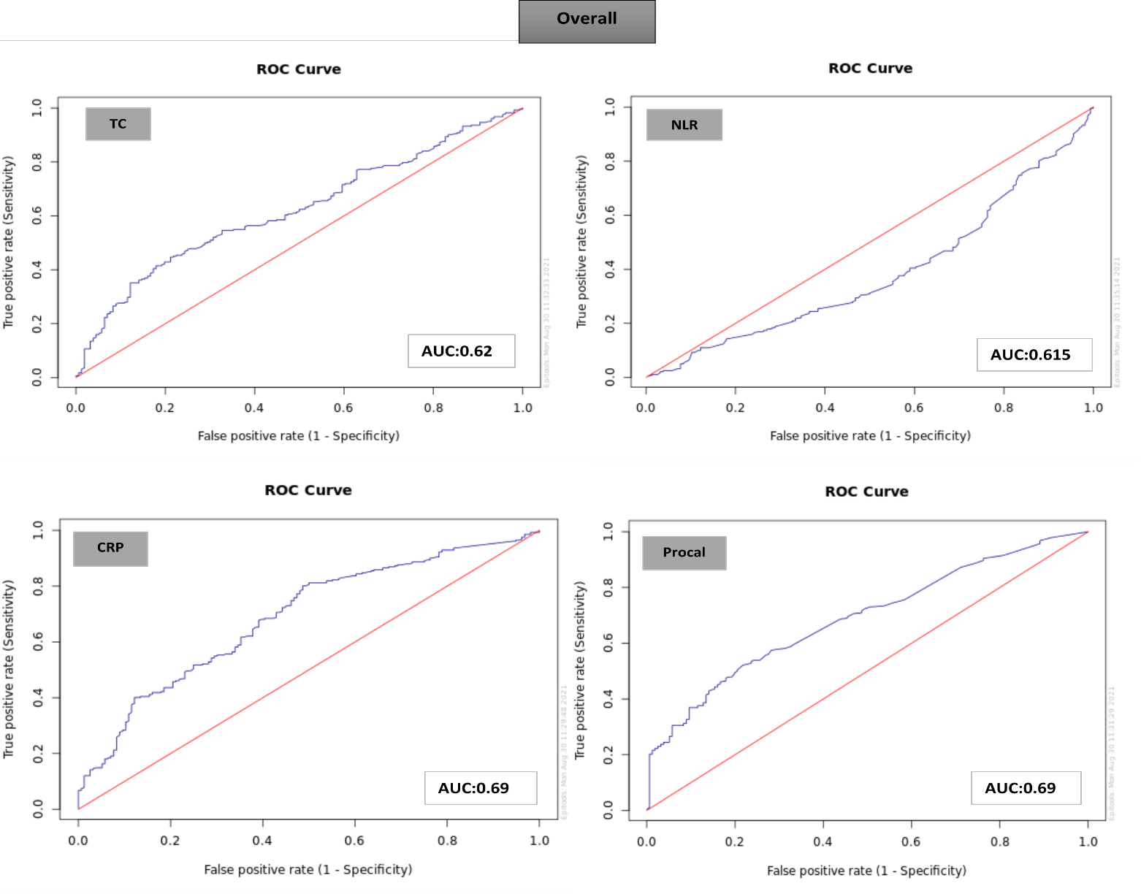

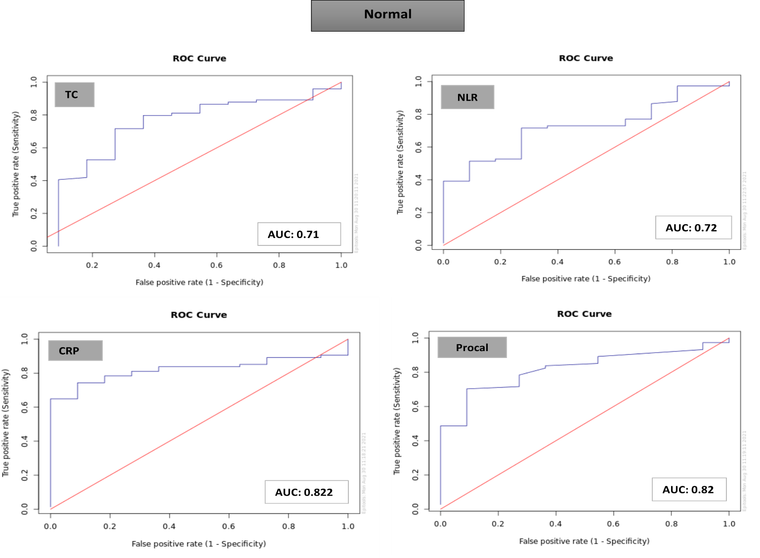

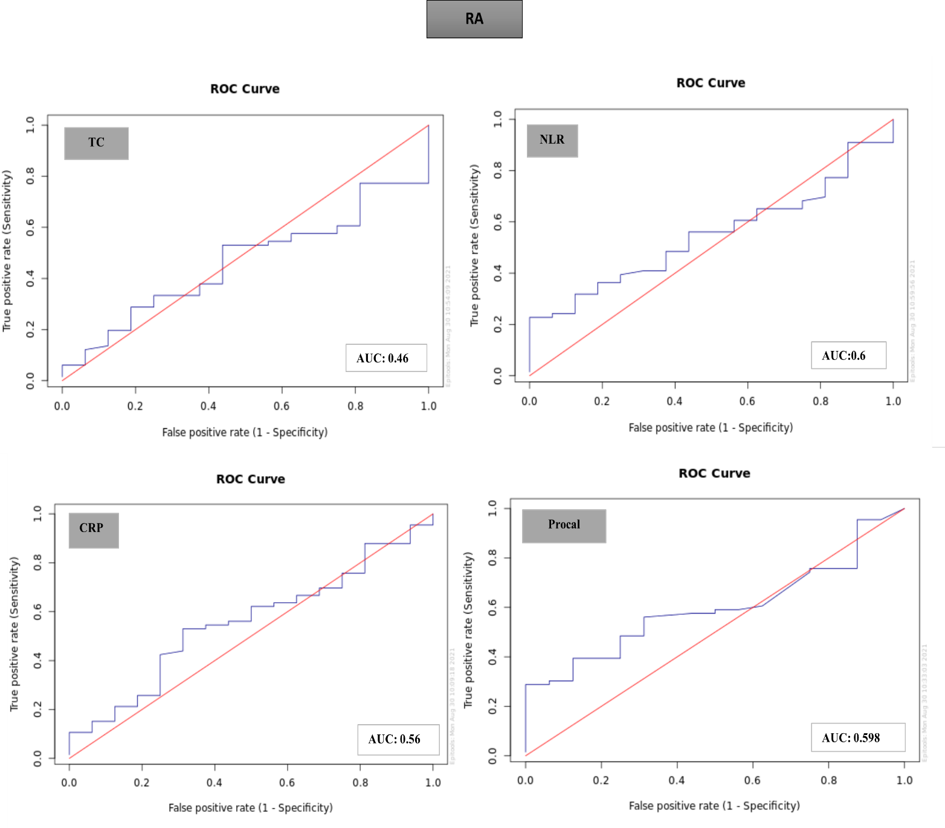
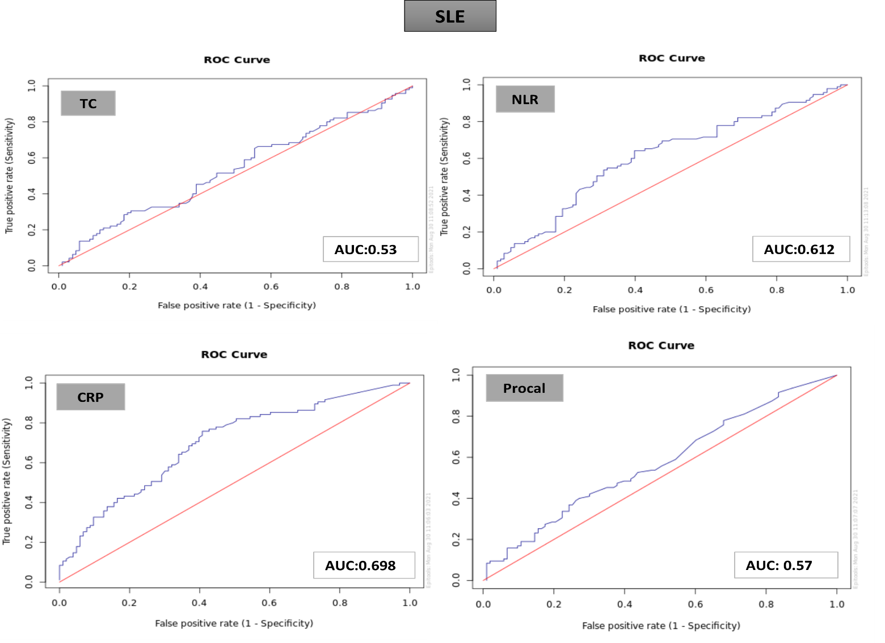

Normal - patients without Auto-immune disease

