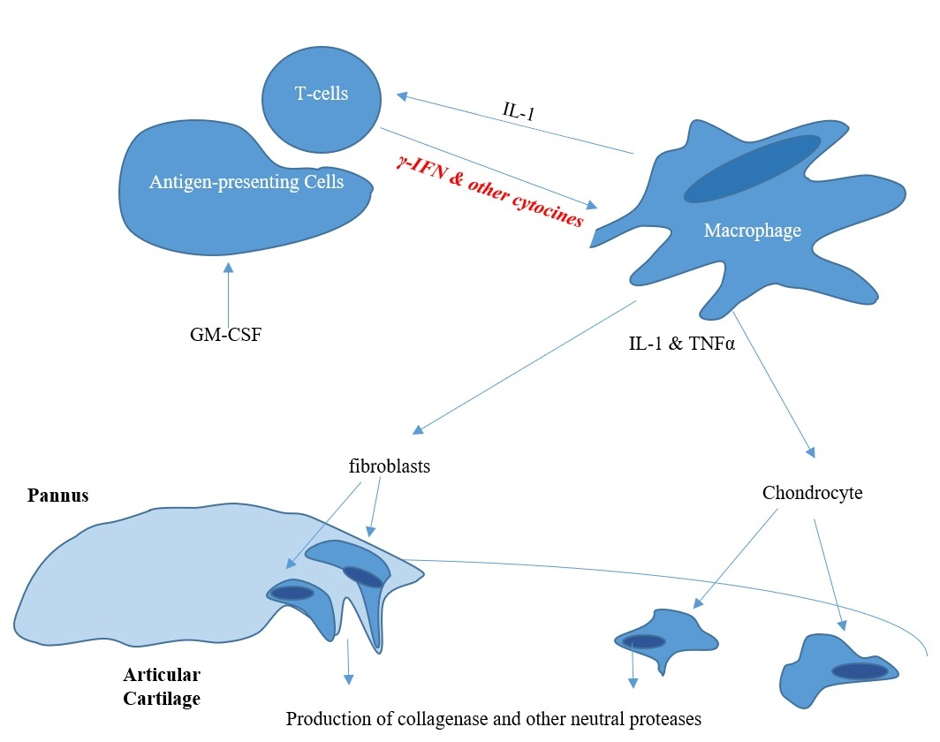

**Figure 2. Stimulatory or agonist effects of cytokines on cell-cell interactions in rheumatoid synovitis. T cells, macrophages, and fibroblasts are present in the rheumatoid pannus. Enzymes, such as collagenase and other neutral proteases, are secreted by synovial fibroblasts and chondrocytes, and result in destruction of cartilage, bone, and periarticular structures.**