FIGURES and FIGURE LEGAND:
FIGURE I
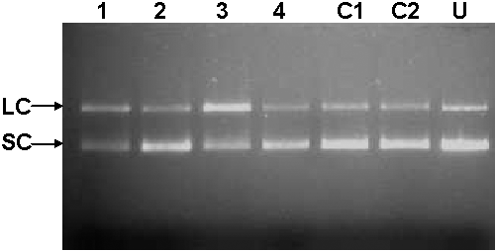
Figure I: DNA hydrolysis activity of IgM Abs. Agarose gel (1%) reveals degradation of super coiled (SC) DNA to linear form (L). Purified IgM Abs (2 µg) was incubated with the substrate plasmid DNA in the reaction buffer for 2½ h. Lanes: 1- 4, RA patients; C1 & C2 – Healthy donors; U- DNA alone incubated in the reaction buffer.

FIGURE II
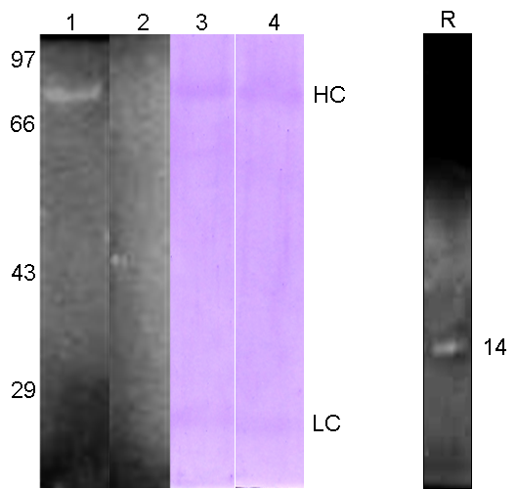

Figure II: RNA in-situ gel under reducing conditions. Hydrolysis of yeast total RNA by IgM Abs purified from RA patient and healthy control. Clear zone indicates the RNA hydrolysis and coomassie staining of the same gel reveals the protein bands which superimpose the active zone. Lanes: 1 & 3, RA patient IgM; 2 & 4, healthy control IgM; R-bovine pancreatic RNase A. H-Heavy chain (70KDa) and L-Light chain (25KDa).

FIGURE III

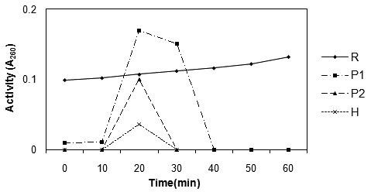

Figure III: Comparative thermal inhibition assay. IgM Abs purified from RA sera and healthy donor was incubated with the substrate yeast total RNA. Activity exhibited by RA patients, healthy donor and a positive control bovine pancreatic RNase A is shown.
R- Bovine Pancreatic RNase A (♦); H - Healthy donor IgM (×); P1 (■) & P2 (▲) – IgM from different RA serum.

